OSU CS373 – Winter 2018

Student: Joaquin Saldana

Lab 1

**Preparation**

This week in Lab 1 we were instructed to run the executable evil.exe. Prior to running the .exe I opened up the following applications:

* Flypaper to block all TCP/IP traffic and block any executables or processes from exiting
* FakeNet which listens on various ports and monitors the attempts to connect to these ports to the outside word, or in other words the HTTP requests to these ports
* Process Monitor that monitors a process as it’s executed on Windows. In particular what it’s doing and how, and the registries it’s using
* Process Explorer, a useful tool to complete a string dump of the process
* AntiSpy which produces an in depth view of the processes running on the machine

**Observations**

Prior to executing the malware I did a quick view of the scheduled tasks to determine if any changes were made after the malware was executed. Below is an image of the scheduled tasks before the evil.exe was executed:

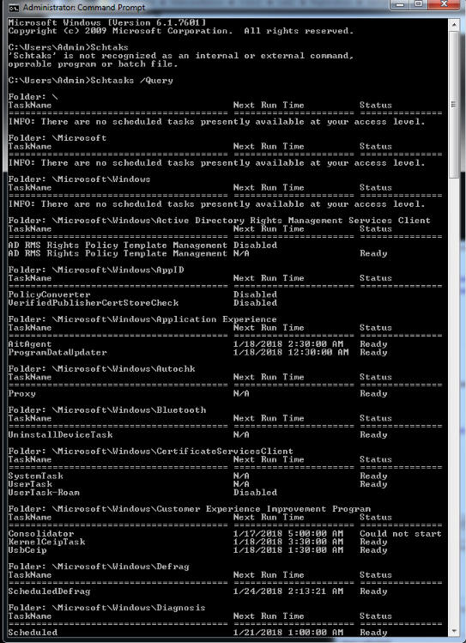

Per some research on Google, most of these processes are routine for Windows. Shortly after the evil.exe was executed, the following tasks were scheduled while others were removed altogether:



In addition, a review of the FakeNet logs shows several HTTP GET requests to various URL’s that seemed suspicious. Below is a timeline of the attempts:

1. A DNS query to the URL mzf2008.blog.163.com which an HTTP GET request to the extension /blog/3559978620114187268502/
2. Another DNS query to the URL [www.hisunpharm.com](http://www.hisunpharm.com) thru port 80, again an HTTP GET request to the extension /files/File.product/pao.exe. This seemed like an obvious attempt to download another executable. This leads me to believe the evil.exe file is a dropper.
3. It made another DNS query to the host timeless888.com with an HTTP GET request to the extension /sun.txt. Not sure what this means just yet or what the .txt file contained.

Below is an image of the TCP/IP traffic discussed above:



A review of the Process Monitor application showed the evil.exe was creating another executable in the C drive in the Program Files folder.



A quick search via Google found that the tongji2.exe file is indeed a virus. A string dump of the tongji2.exe file showed the following:





I did not find anything that was an immediate red flag, although I know this executable is not indigenous to the operating system and is indeed an artifact of the malware.

Additionally, a review of the C drive reveals the malware created more artifacts and in this case it created a folder, C:\ntldrs which the following a file titled svchest.exe, a close mirror to the indigenous executable, svchost.exe.



A attrib command search in this directory found a hidden file titled funbots.bat.



After I finished analyzing the behavior of the malware I restored the VM to it’s original state via the snapshot taken prior to deploying the malware. This time rather than attempting to analyze the malware through it’s behavior, I performed a static review of the malware by opening it with McAfee’s FileInsight.

A string dump of the file in McAfee File Insight showed the PE file of the malware created various scheduled tasks every 30 minutes for a 48 hour period. A obvious red flag. Furthermore, I discovered the strings to the URL’s I had observed with the FakeNet application, including the attempts to download the executables. I also found strings that tied the tongji2.exe to the evil.exe malware. I also found various sections of memory with strings that appeared as if they were encrypted and XOR, however attempts to decrypt this malware went unsuccessful.

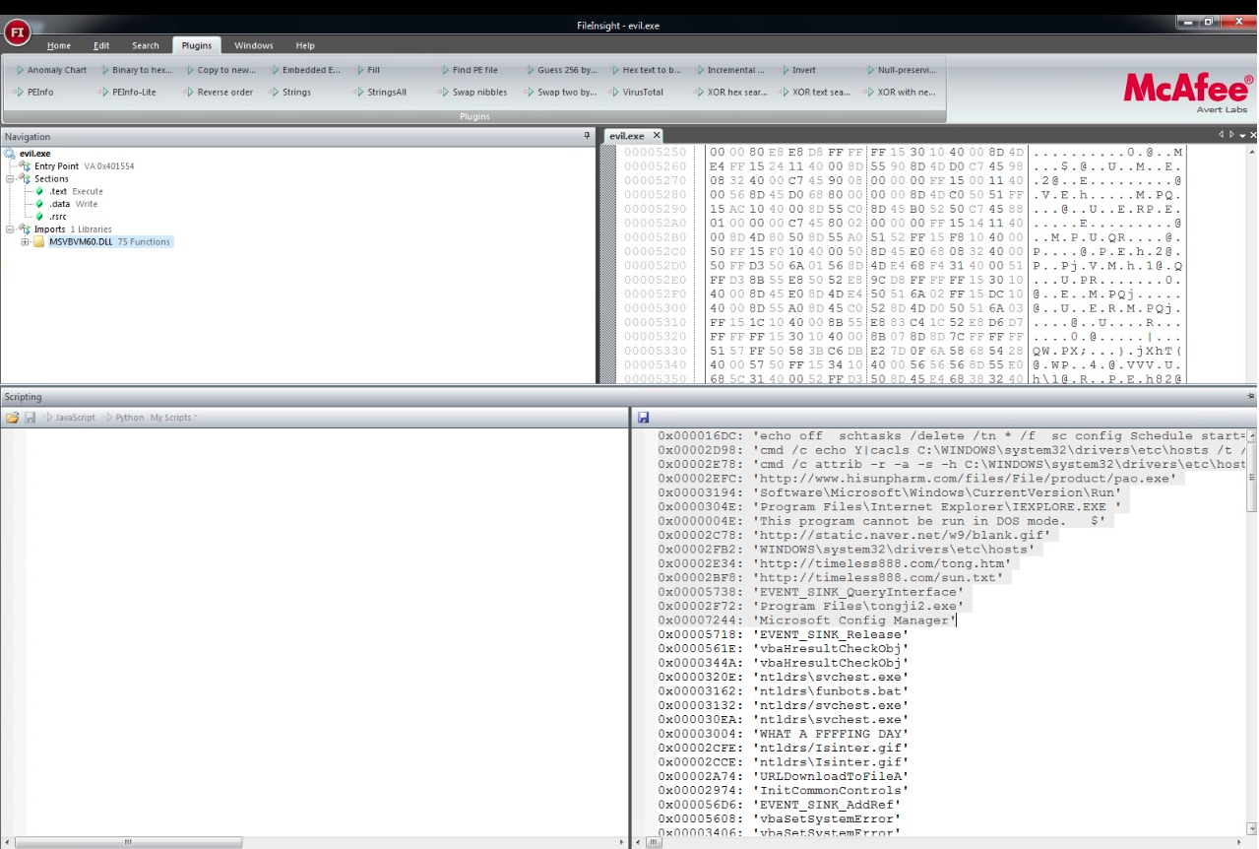

**Conclusion / Opinion**

Ultimately, I believe the malware is attempting to download various infectious files to the machine with the intention of using the machine as a slave via a botnet. My theories are grounded on the naming conventions of the file funbots.bat file found in the ntldrs directory. Furthermore, the scheduled tasks suggest the actor is requesting the machine keep constantly performing a task at a frequent rate. I’m unsure what this task is but if I had to guess, it’s keep constant communication with the master machine.